**Customer Management System**

**What is it?**

* **A customer management system is used to maintain and manage customers’ data. It is used in industries where maintaining and managing relationship with customers is necessary. Some examples of such industries are:**
* **Sales and marketing**
* **Finance and banking**
* **E-commerce**
* **Education**
* **Healthcare**
* **Hospitality and travel**
* **This system is a web application which can be accessed using local area network (LAN).**

**Why is it needed?**

* **In present times, there is a requirement to keep and manage the data of customers so it can be used for the benefit of the organization and the customers.**
* **By working on a project like this one, one can improve his/her programming skills, data management skills, web development skills and other such skills. These skills are required in today’s job market.**

**How to make and develop it?**

* **For developing backend features, tools that are needed:**
* **MySQL (software)**
* **Python (programming language)**
* **SQL (query language)**
* **For developing frontend features (interface) of the database management system, tool that are used are:**
* **Python (programming language)**
* **Streamlit (Package)**

**MySQL Workbench Database**

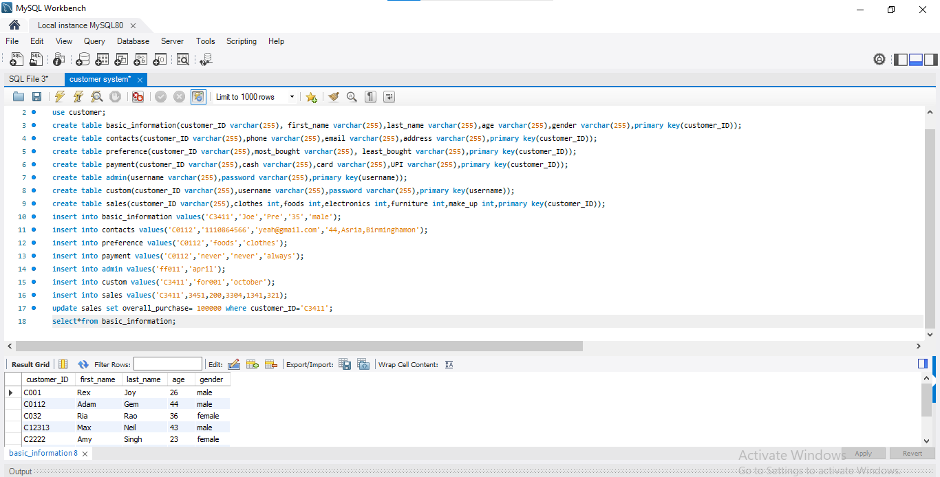

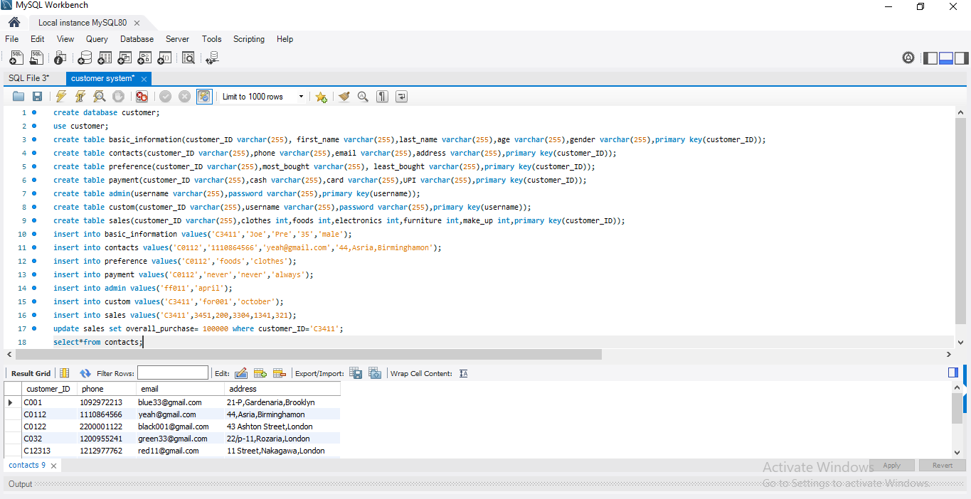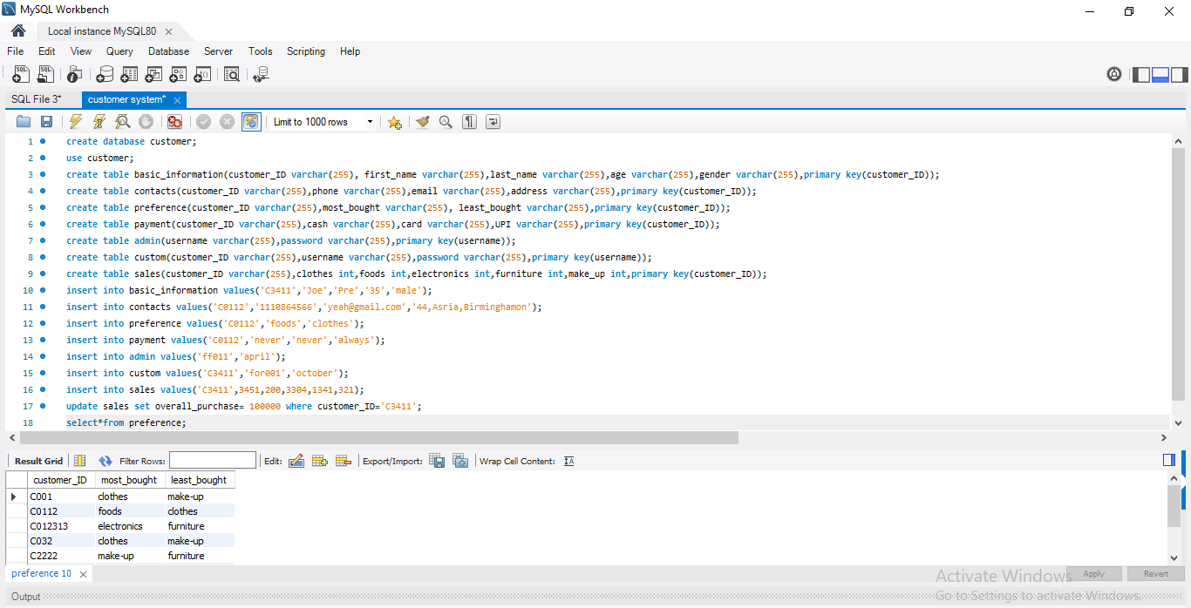

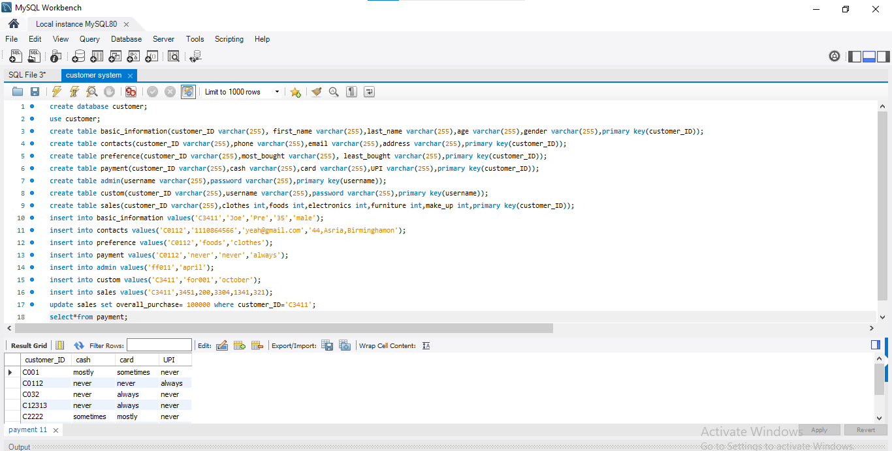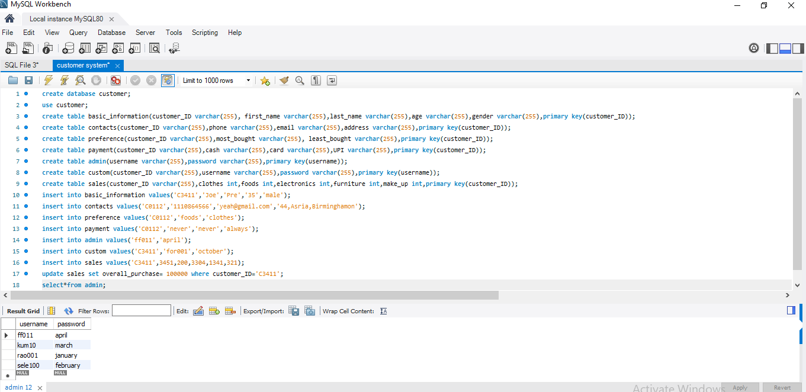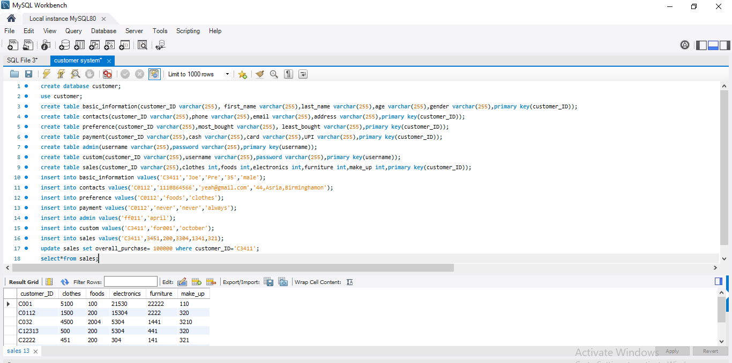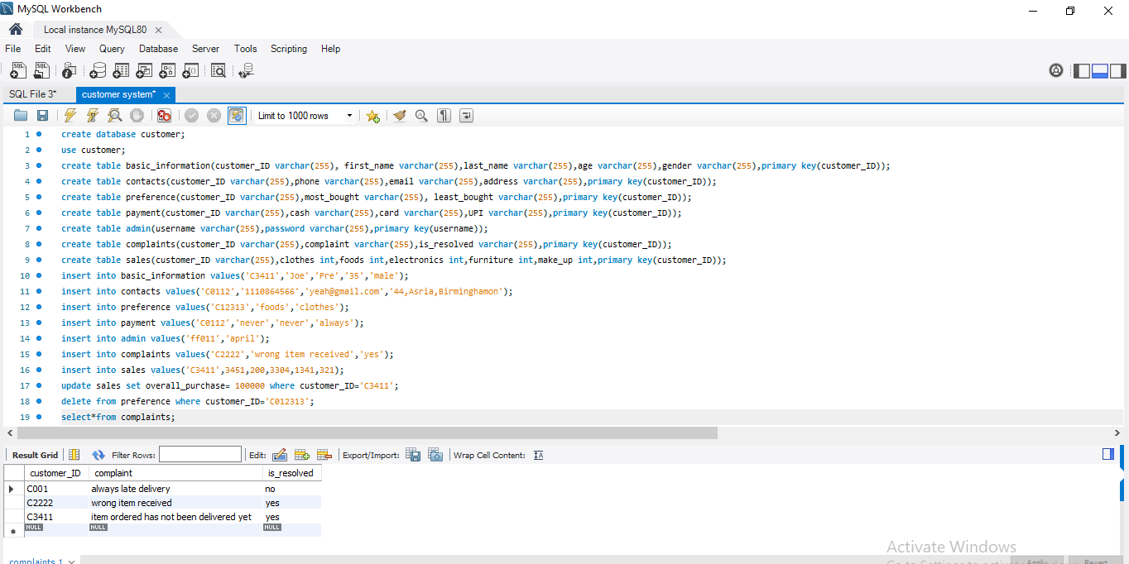

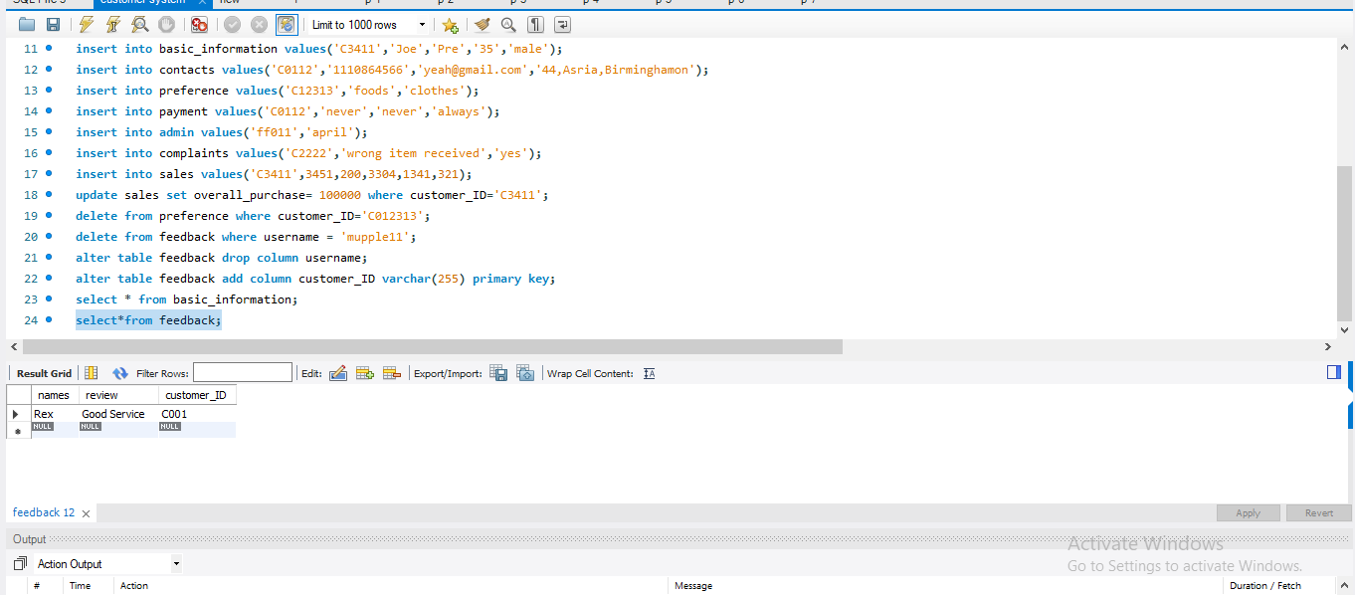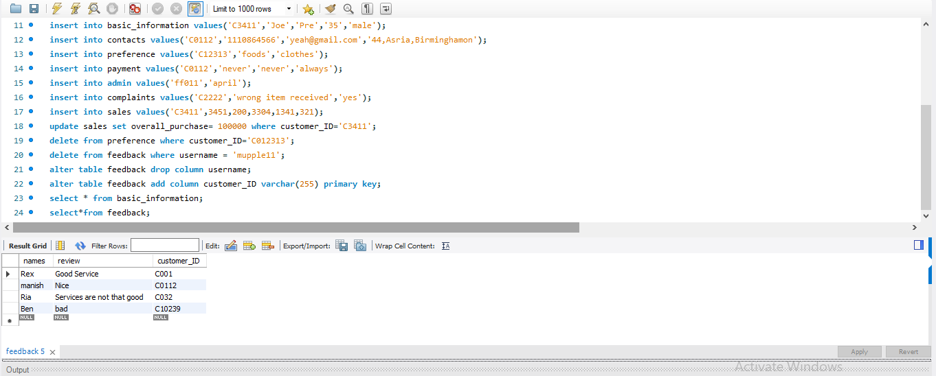

**Python Code for the Project**

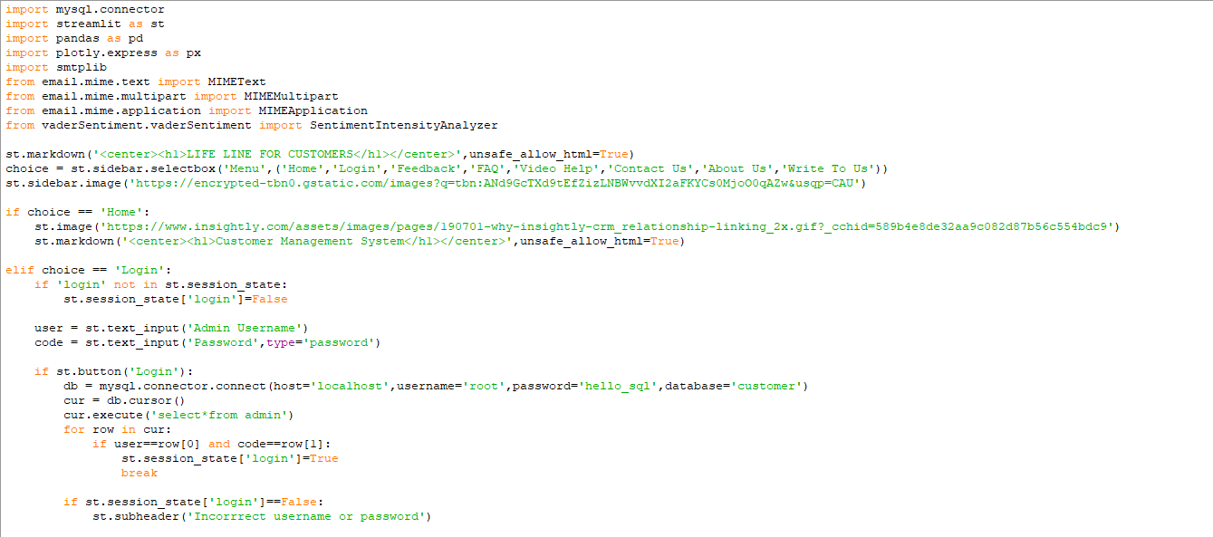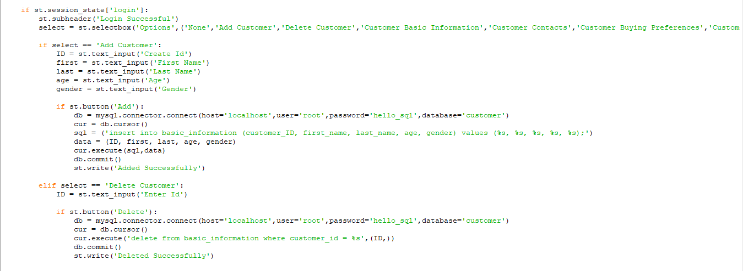

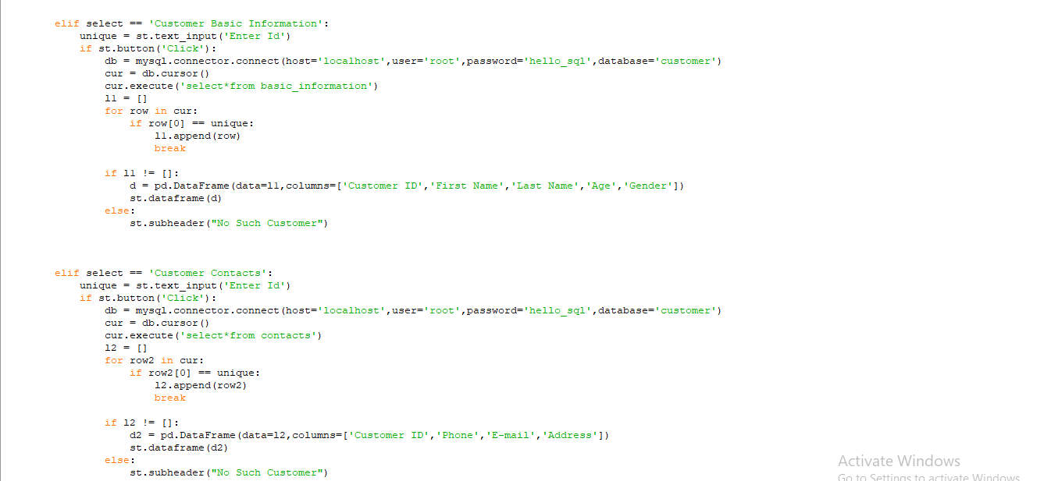

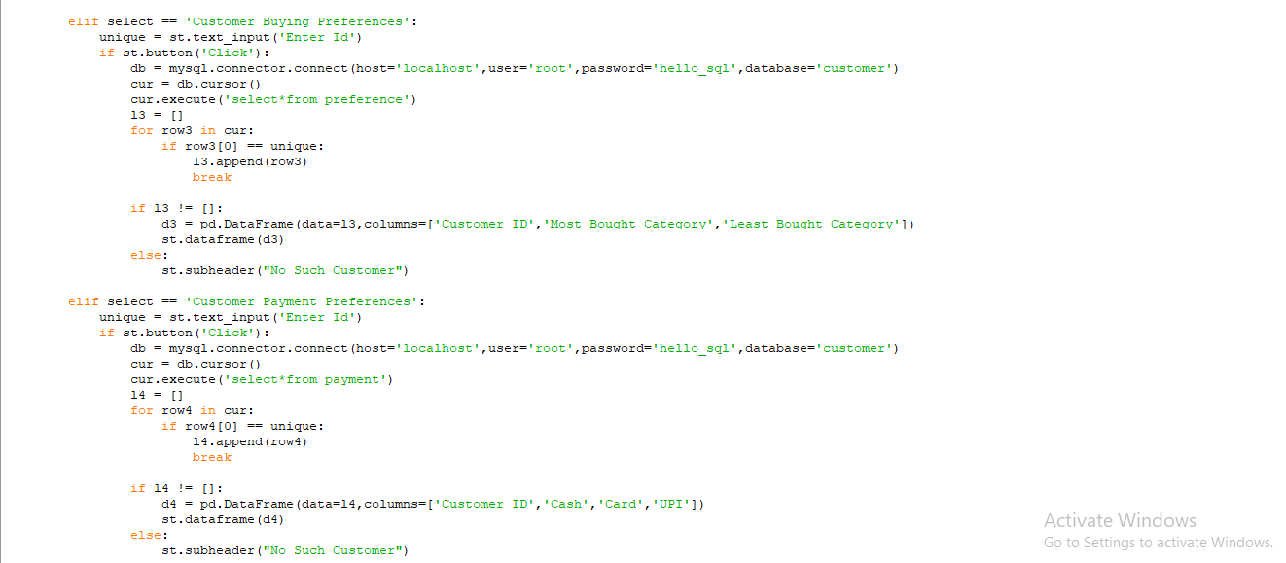

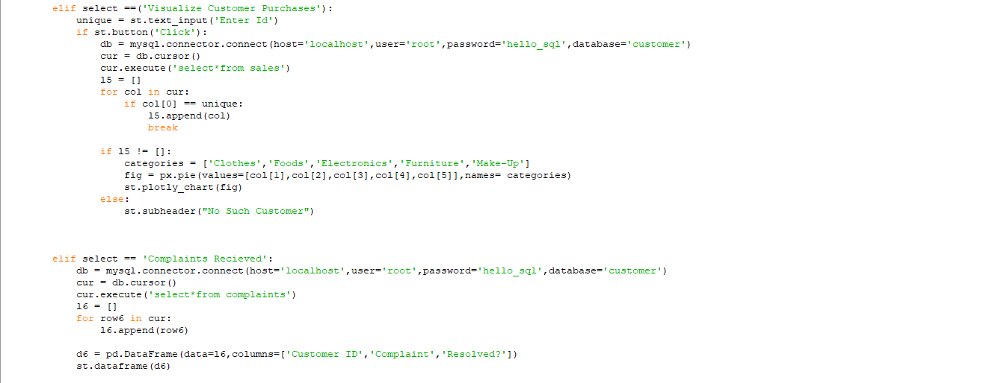

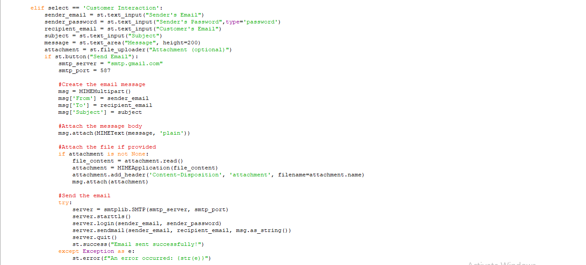

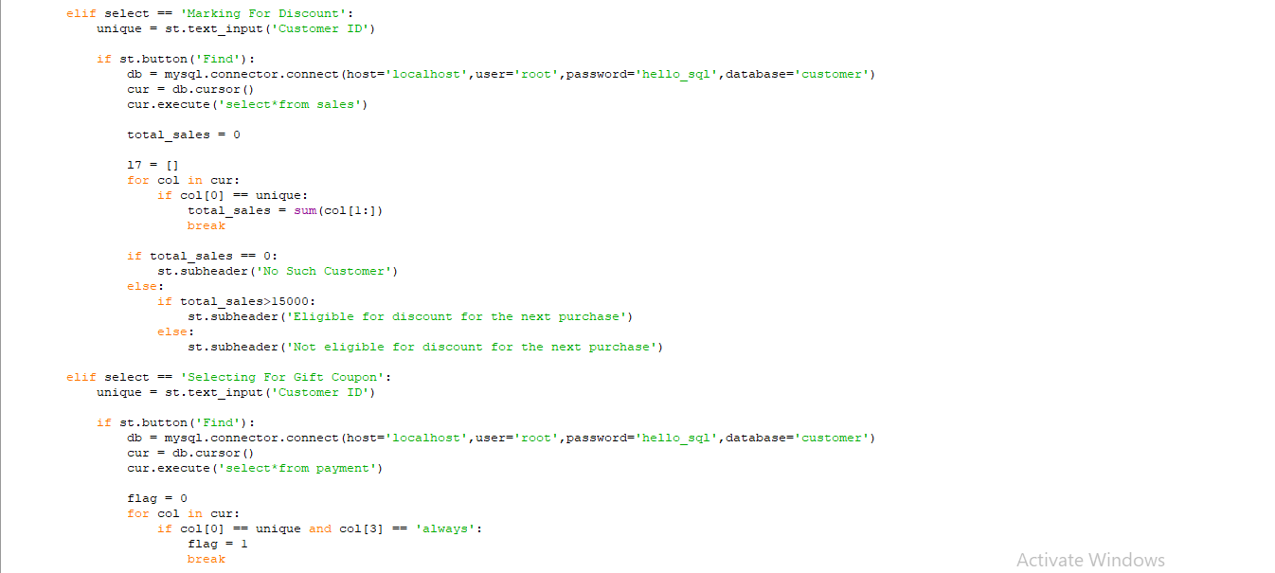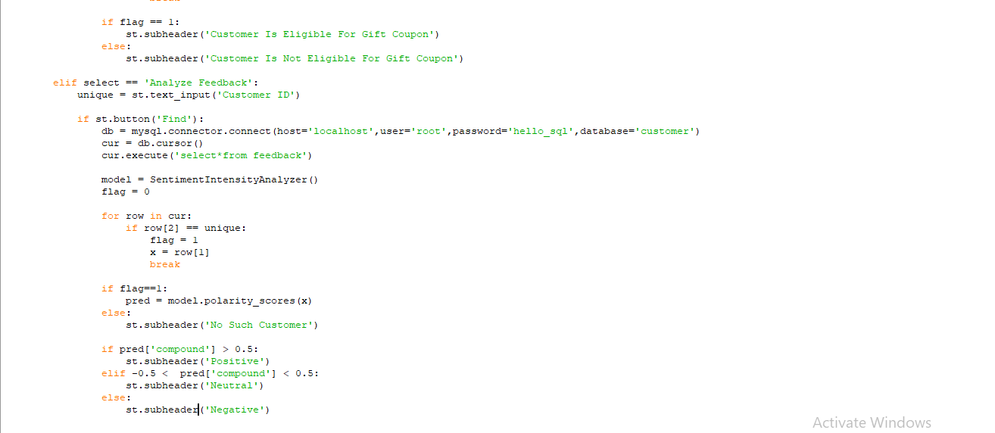

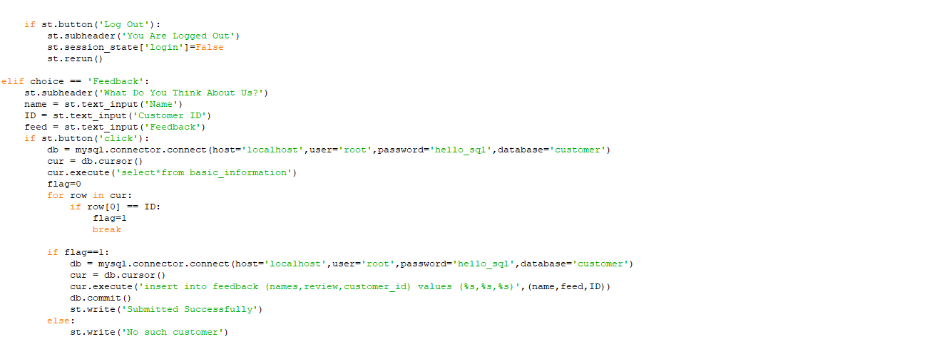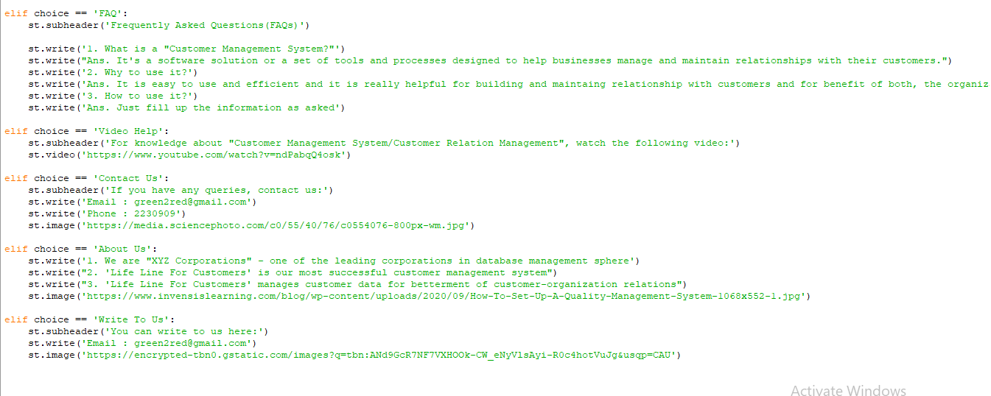

**How Web Application Looks**

**Homepage**

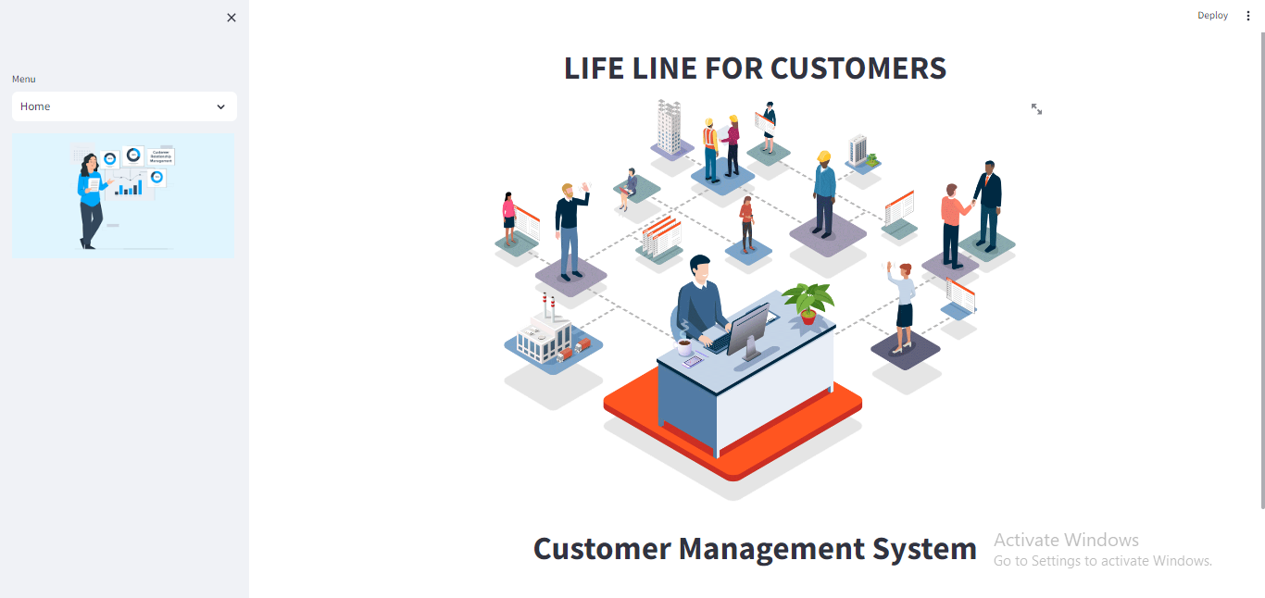

**Login Page for Admins**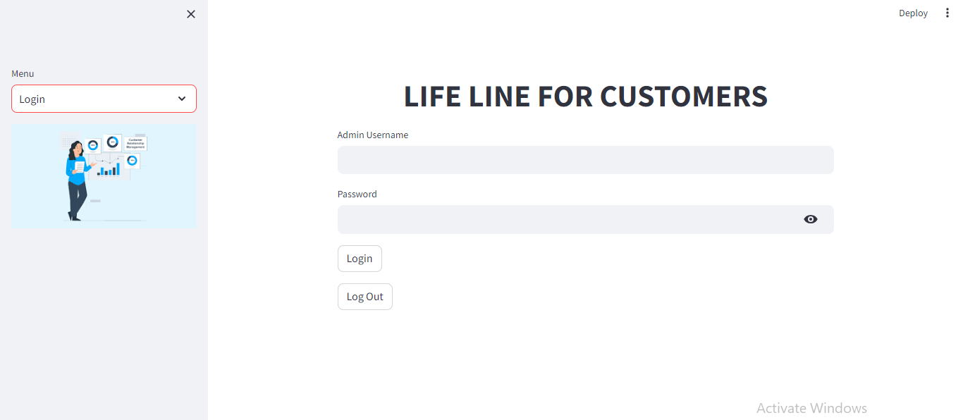

**Successful Login**

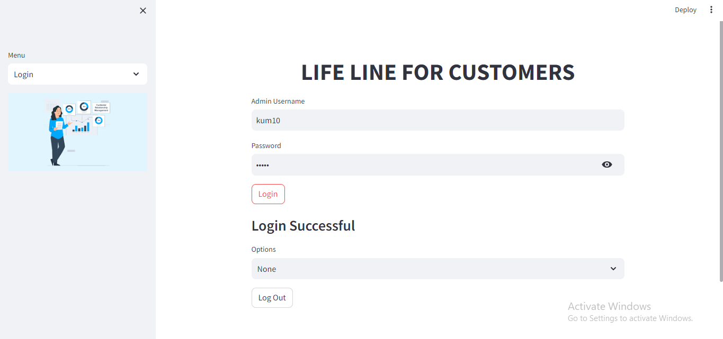

**Adding a New Customer to the Database**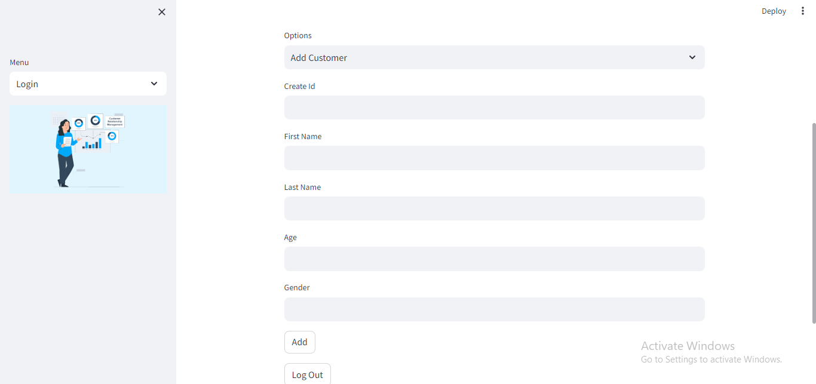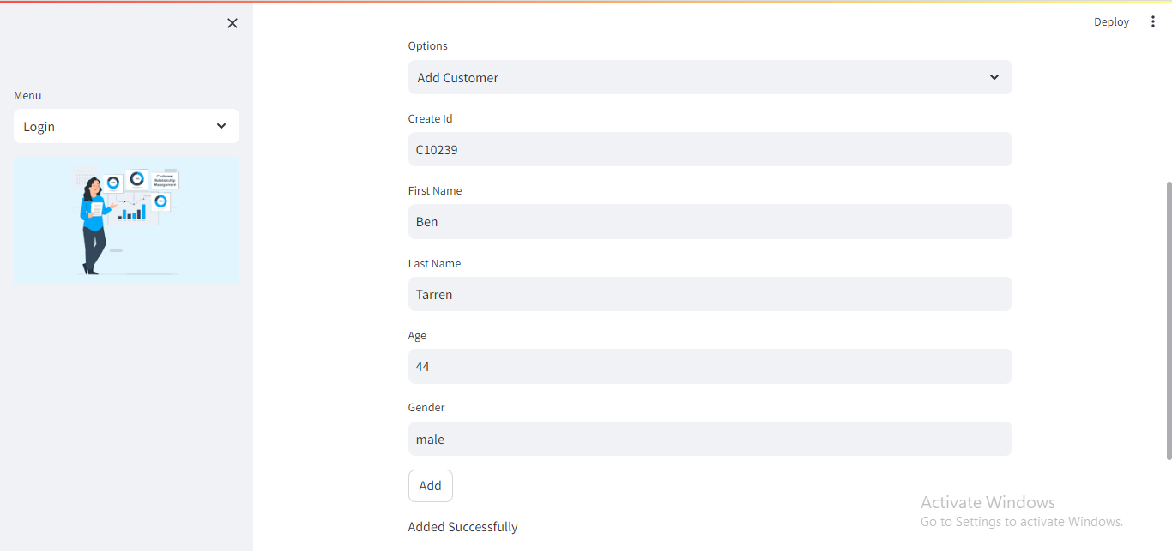

**Proof that the customer has been added to the MySQL Database**

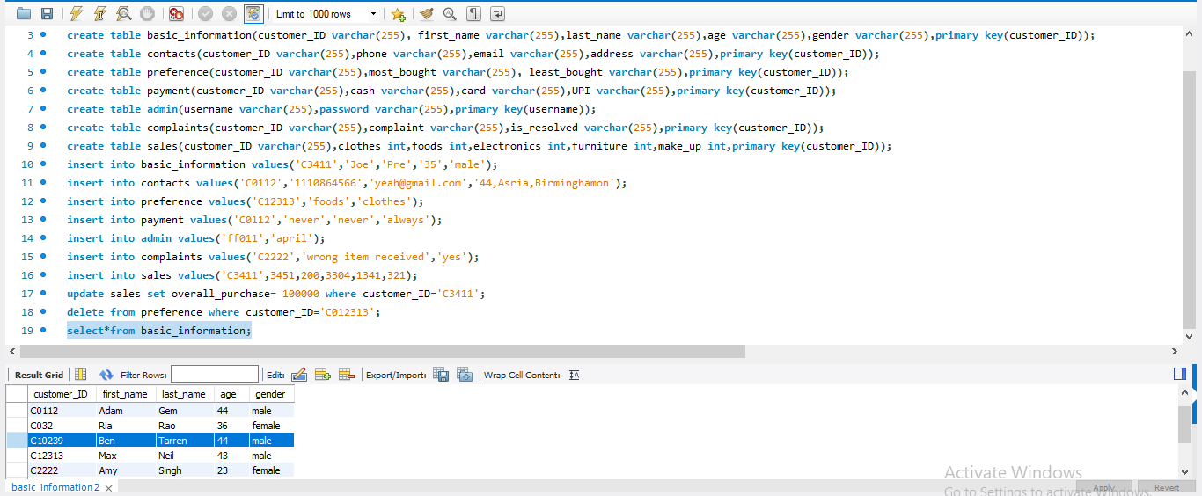

**Getting Different Information about Customers Using their ID** 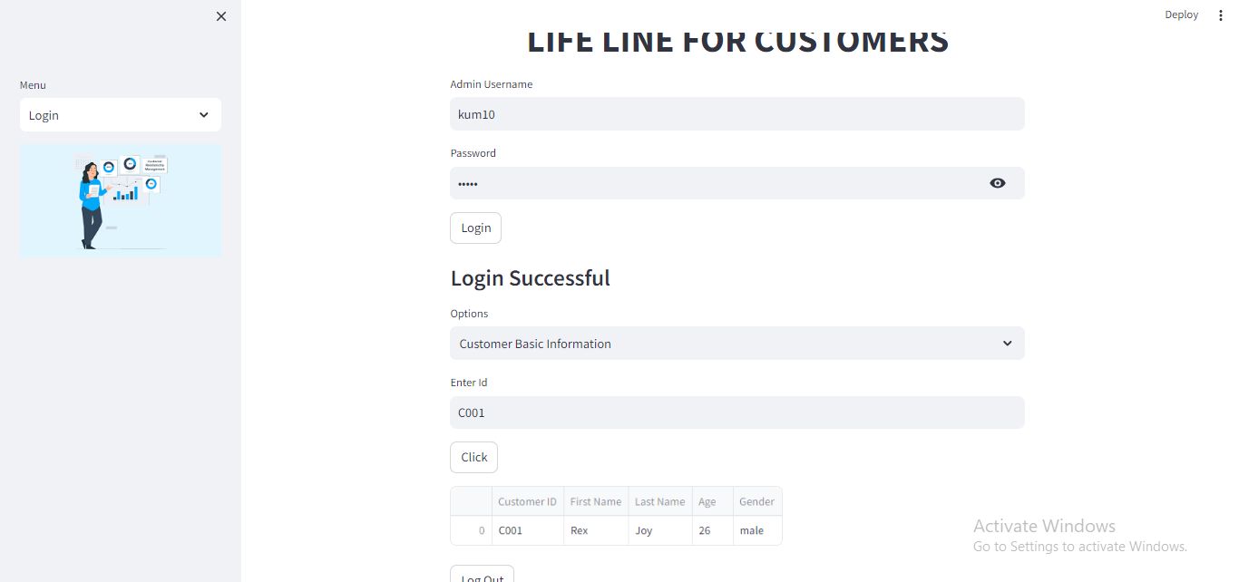 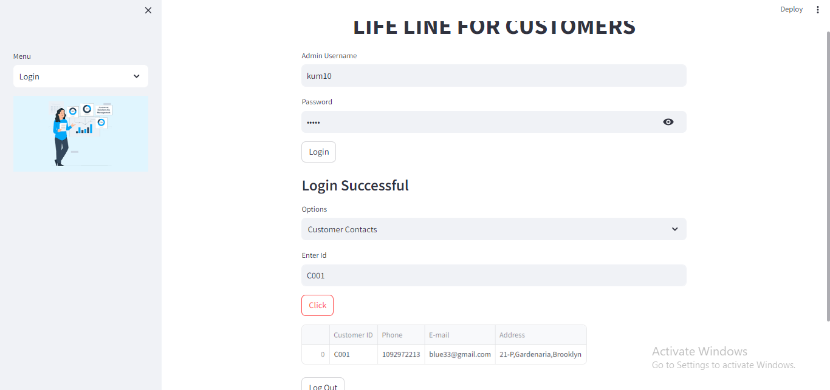

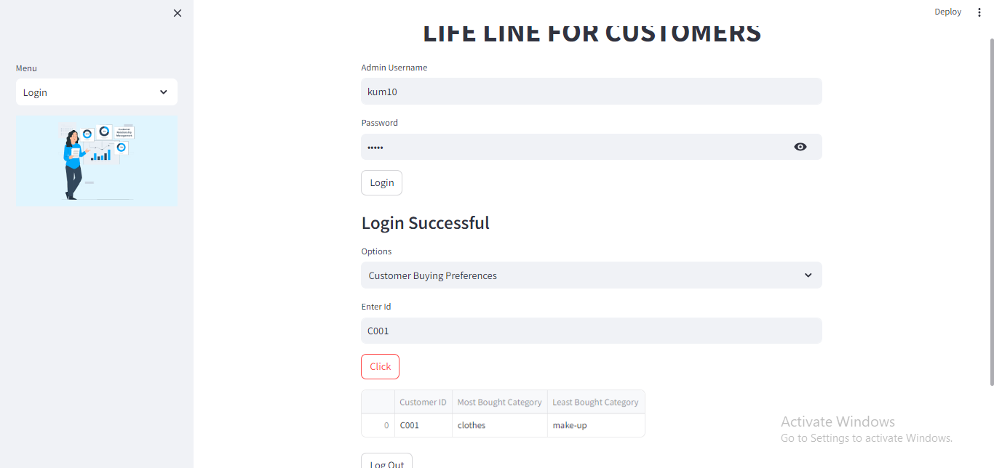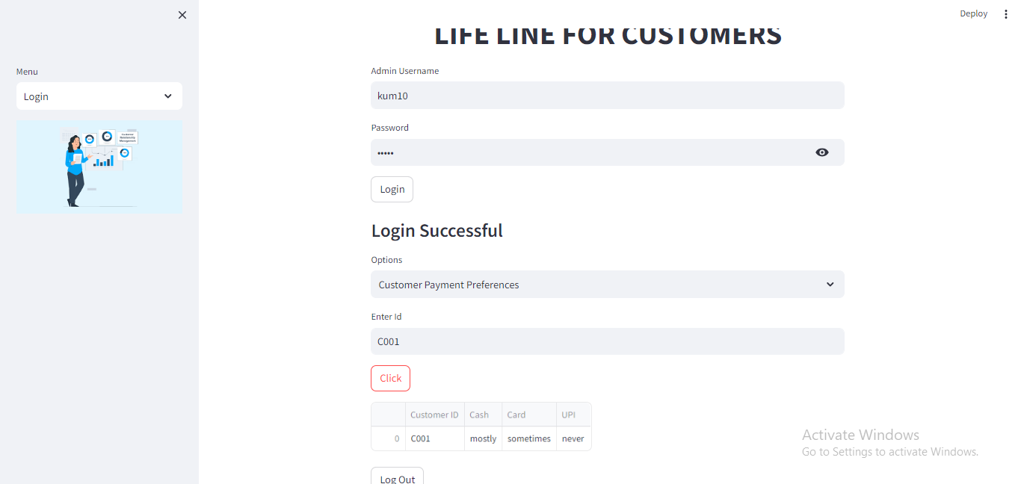

**Visualizing the Purchases of the Customer**

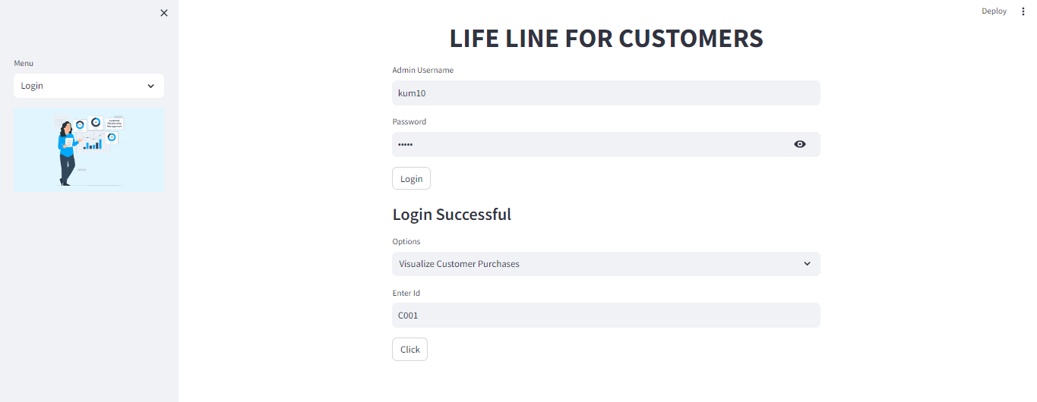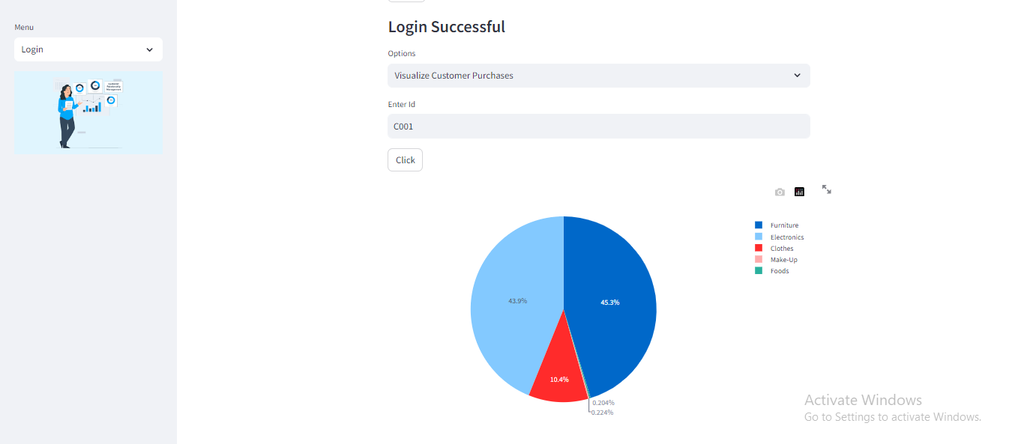

**Seeing the Complaints Received from the Customers**

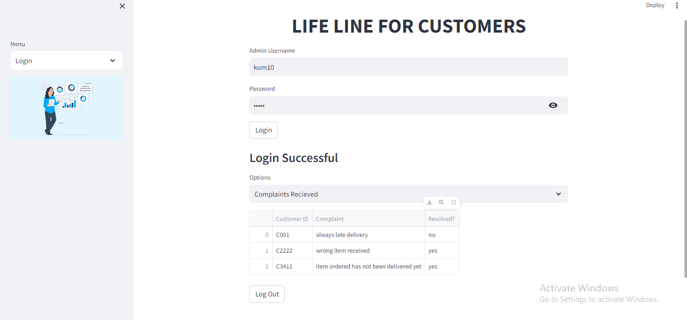

**Sending Mail to a Desired Email**

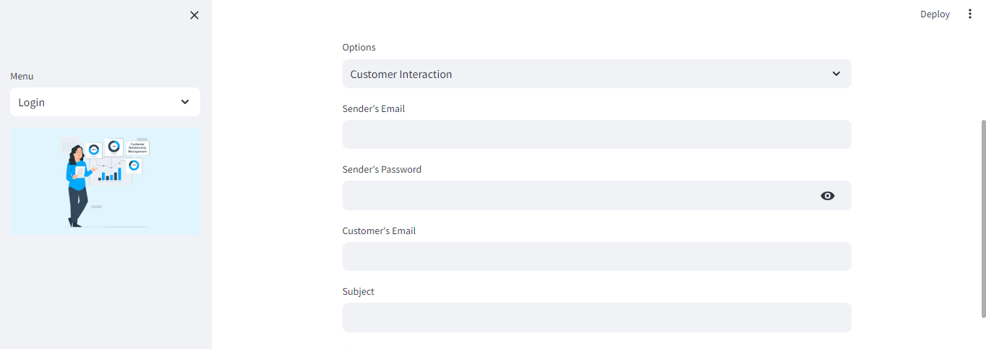

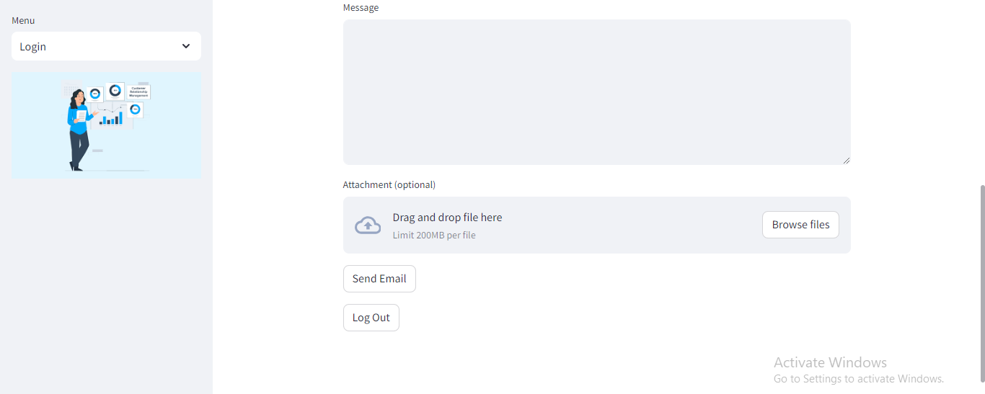

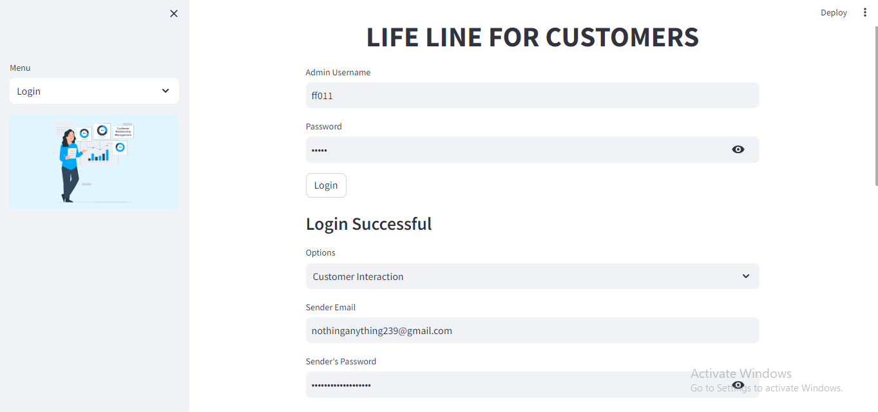

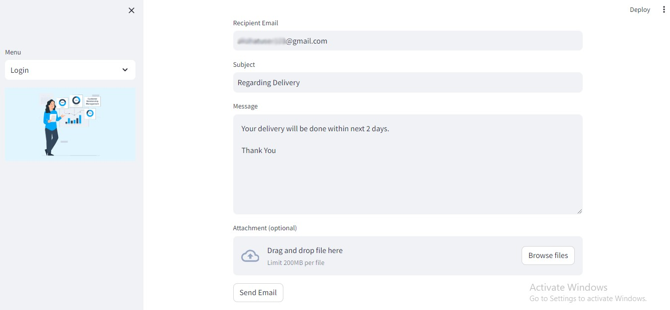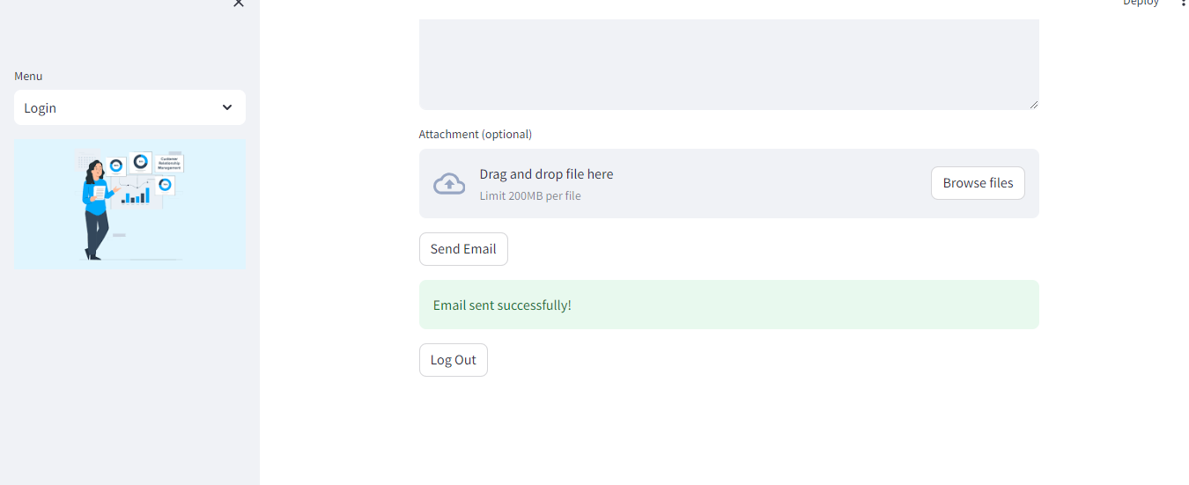

**Proof that the Mail has been sent Successfully**

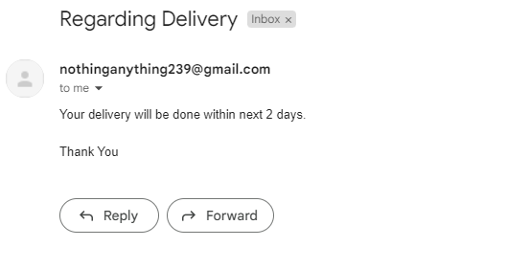

**If an entered Customer Id is not in the Database**

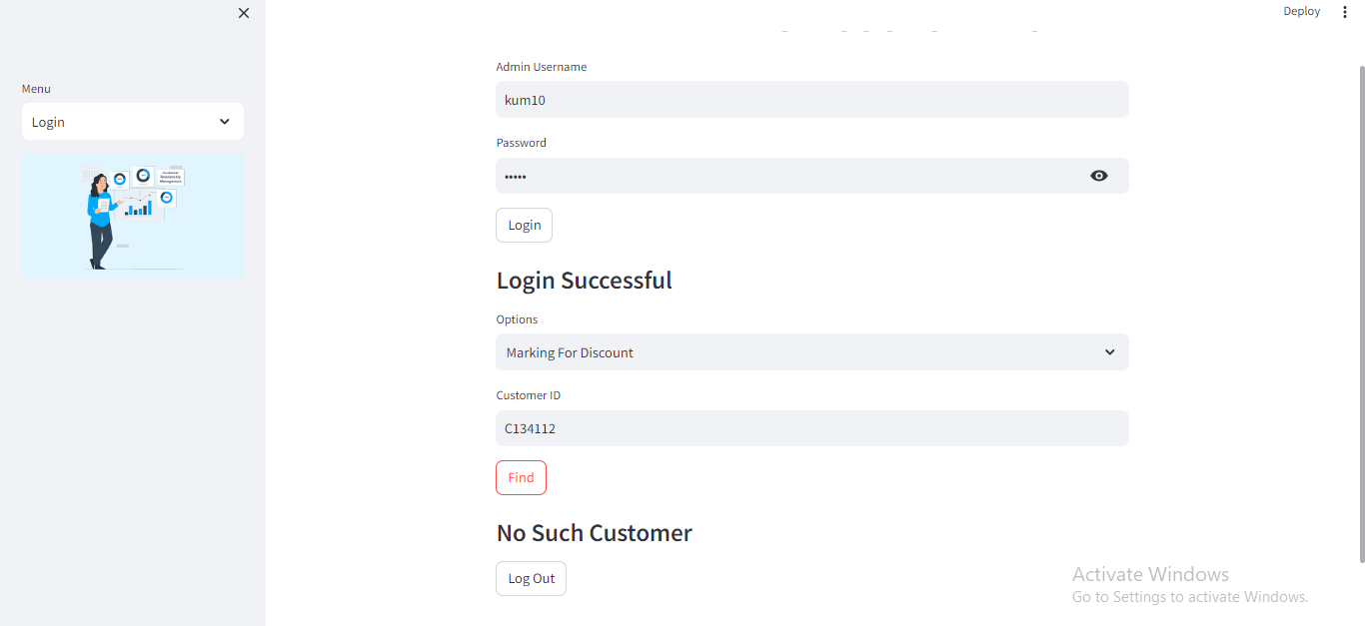

**If an Admin Username or Password is entered that is not in the Database**

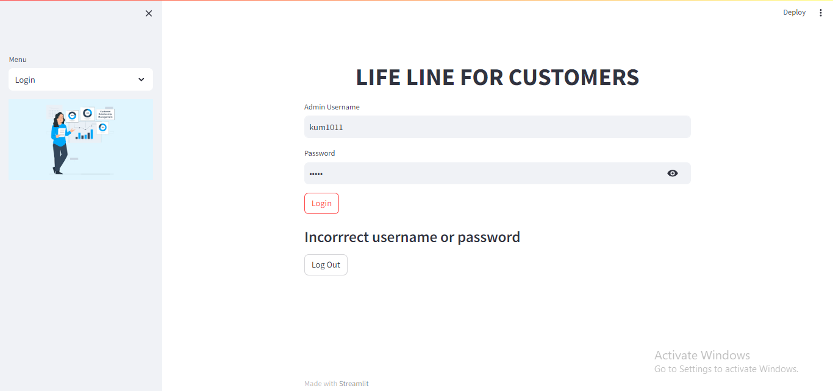

**Marking Customers for a discount in their next purchase who have bought items worth more than 15000 rupees**

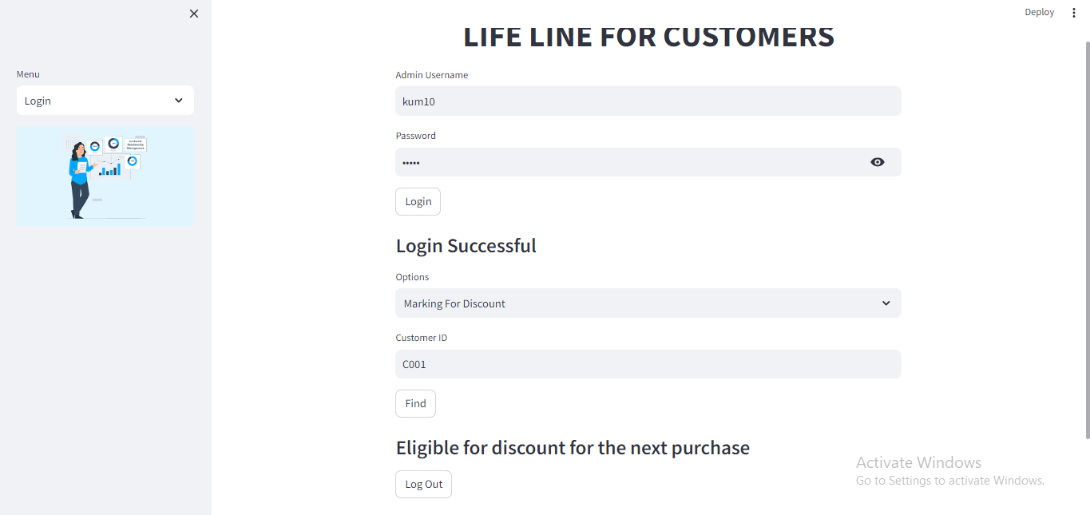

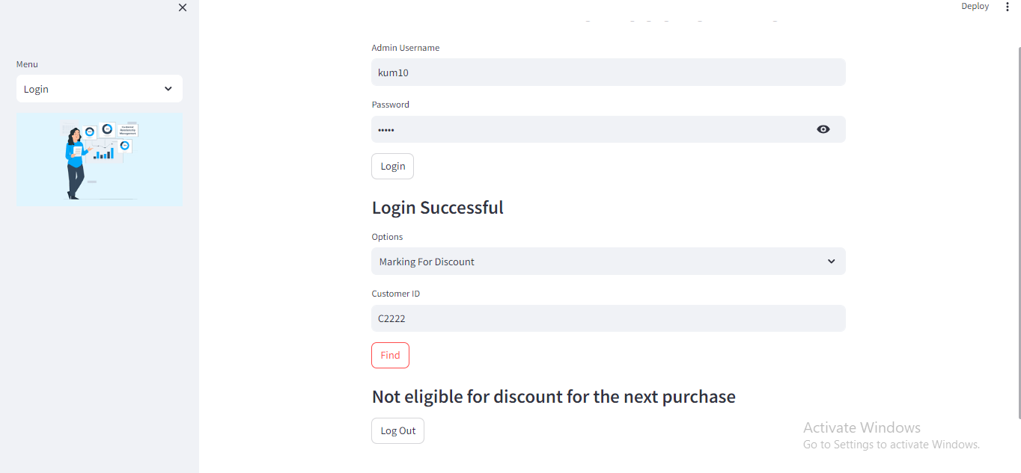

**For deleting an existing customer from the database**

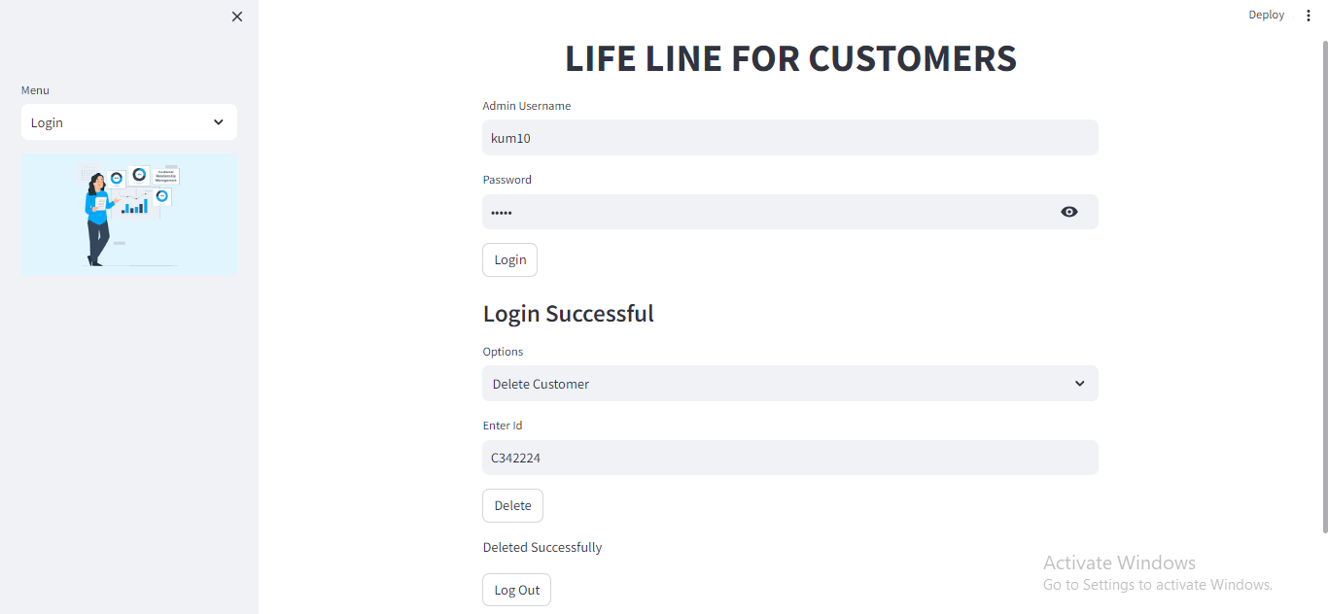

**Proof that the customer with customer id “C342224” does not exist in the database anymore**

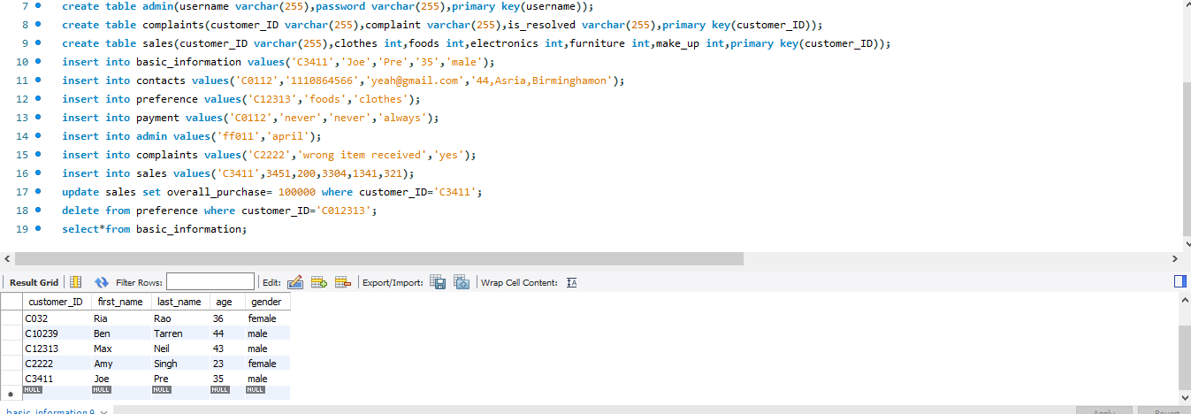

**Selecting Those Customers for Gift Coupon who always pay via “UPI” (using customer IDs)**

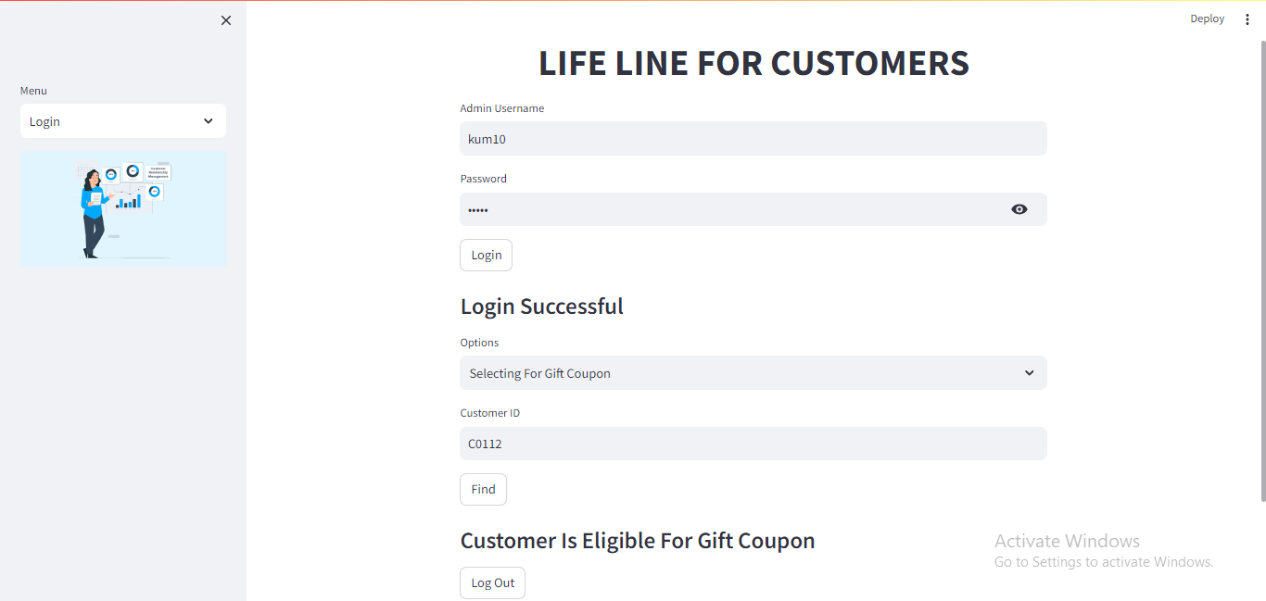

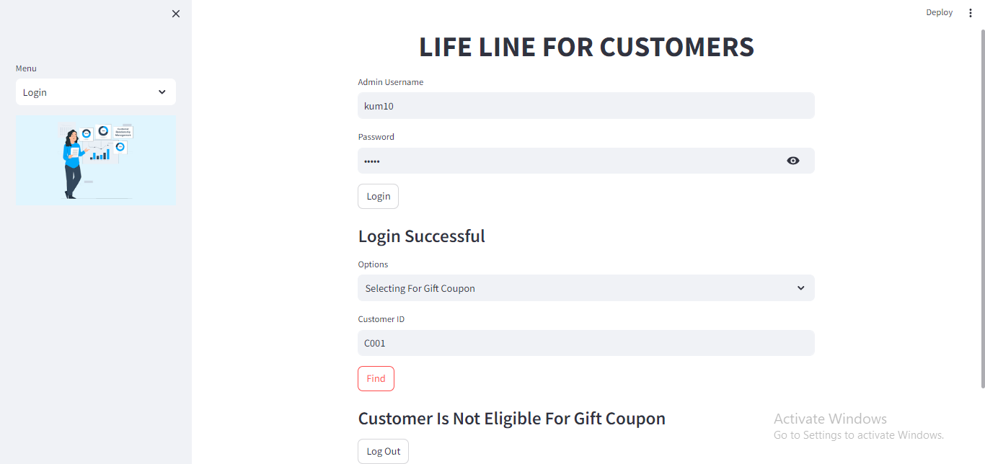

**Analyzing Sentiment of the feedback given by customers**

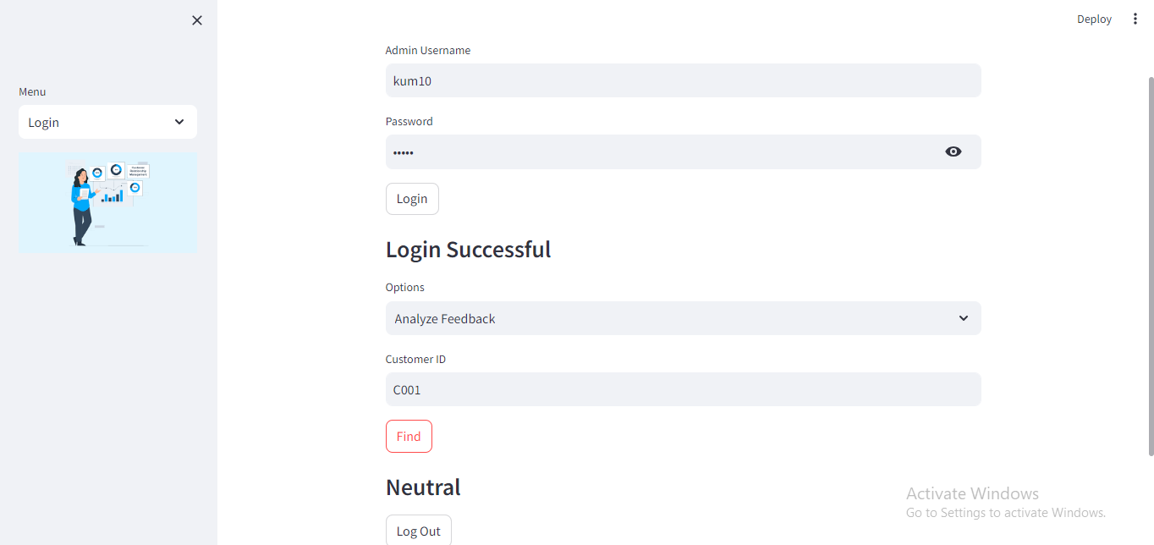

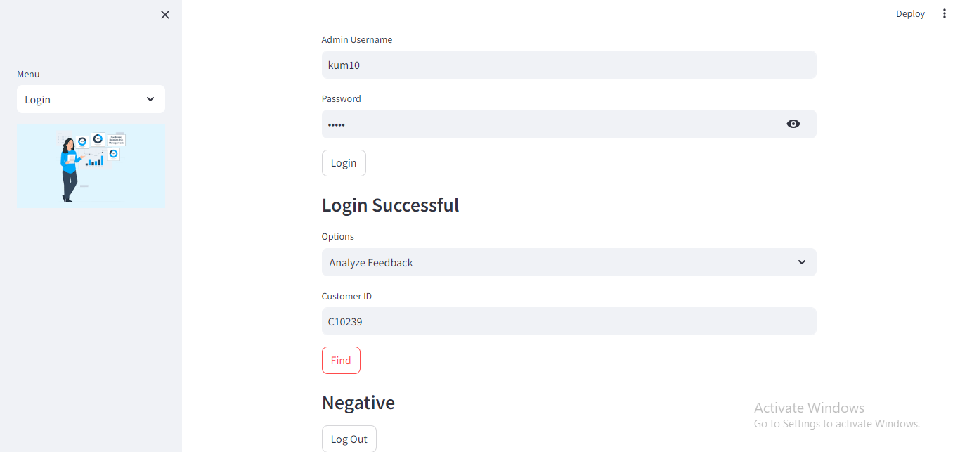

**Feedbacks stored in the database**



**Feedback giving by a customer whose unique ID is in the database**

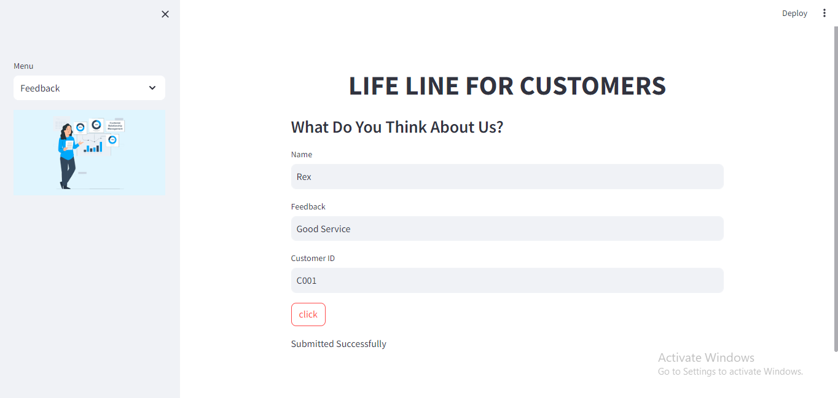

**Proof that Feedback gets stored in the MySQL Database**



**If a customer with invalid ID tries to give feedback (result- No such customer)**

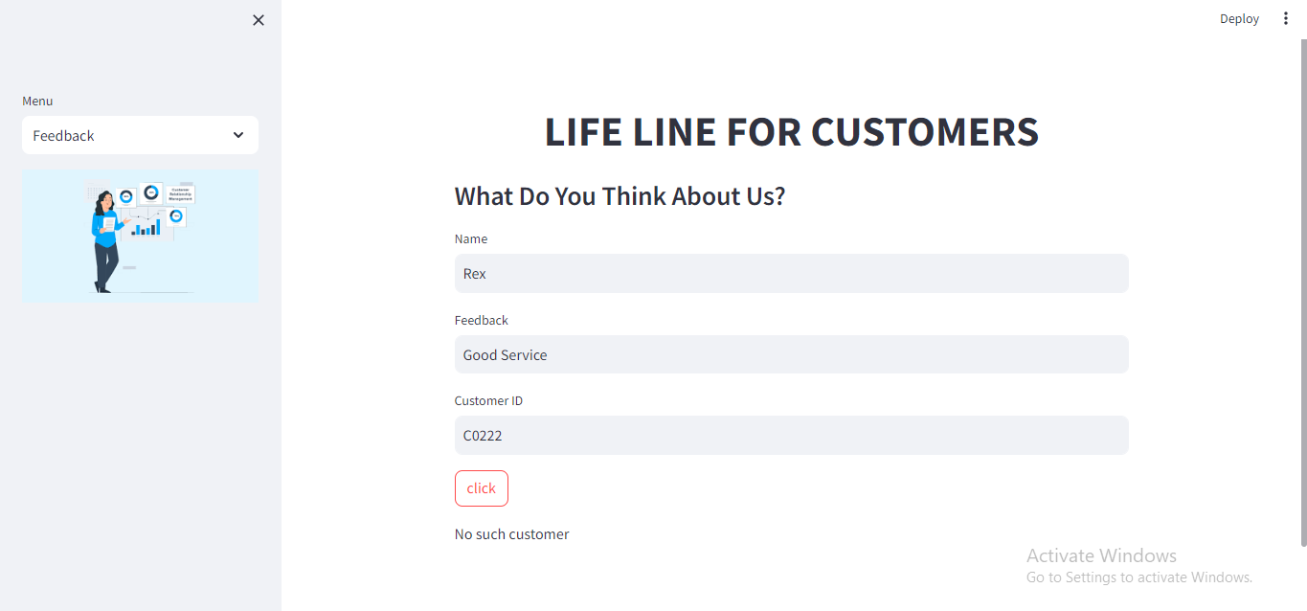

**Some Final Pages regarding help about “Customer Management System” and Information about the company who created this Database**

